K.SANJANA
2505A41L63
1. Two Sum LC-1
https://leetcode.com/problems/two-sum/description/
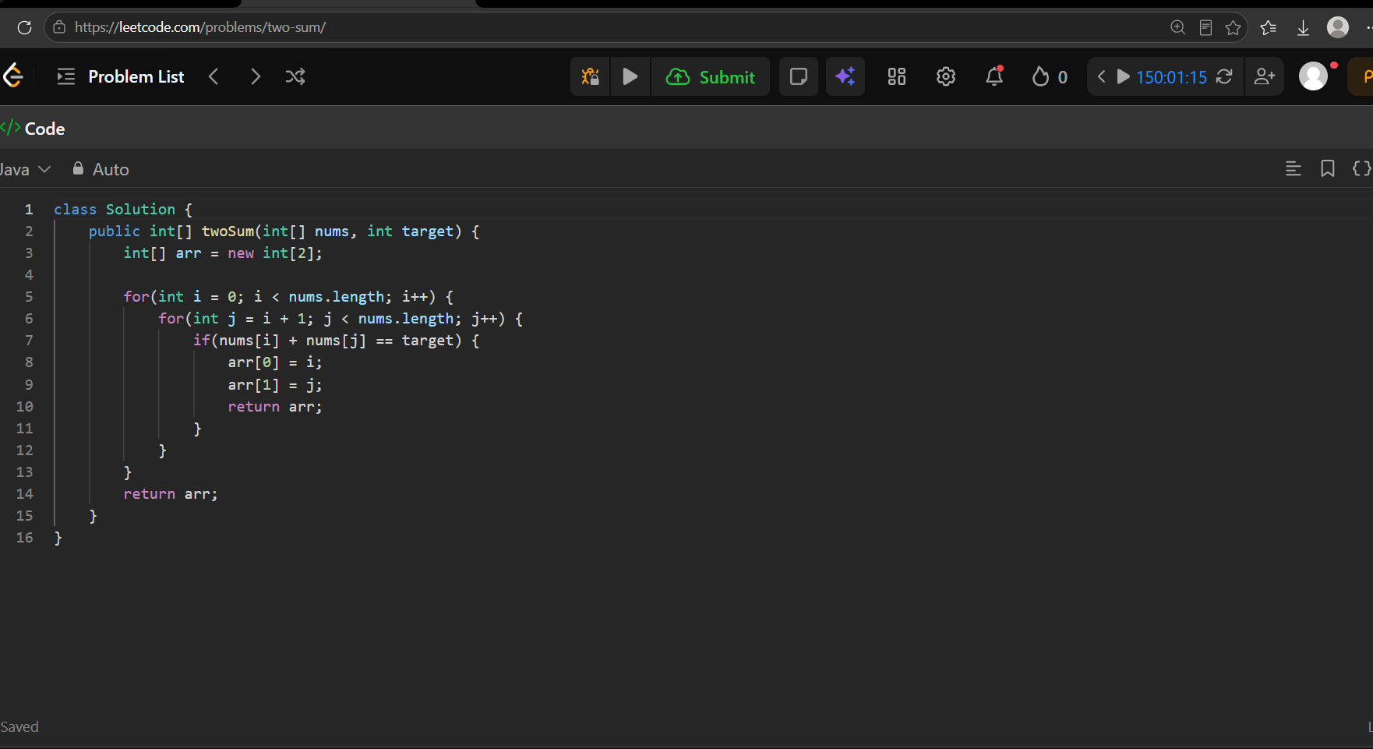
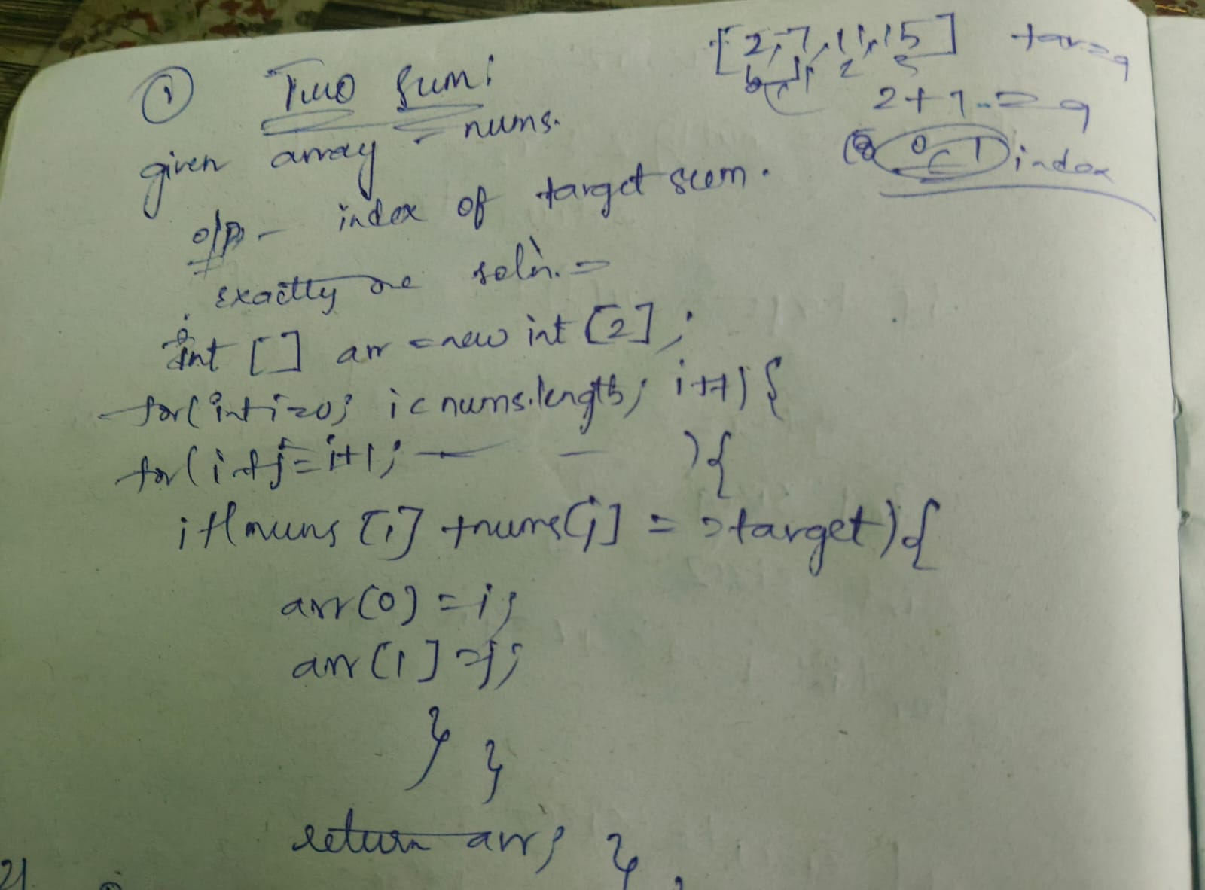

2. Best Time to Buy and Sell Stock LC-121
https://leetcode.com/problems/best-time-to-buy-and-sell-stock/description/
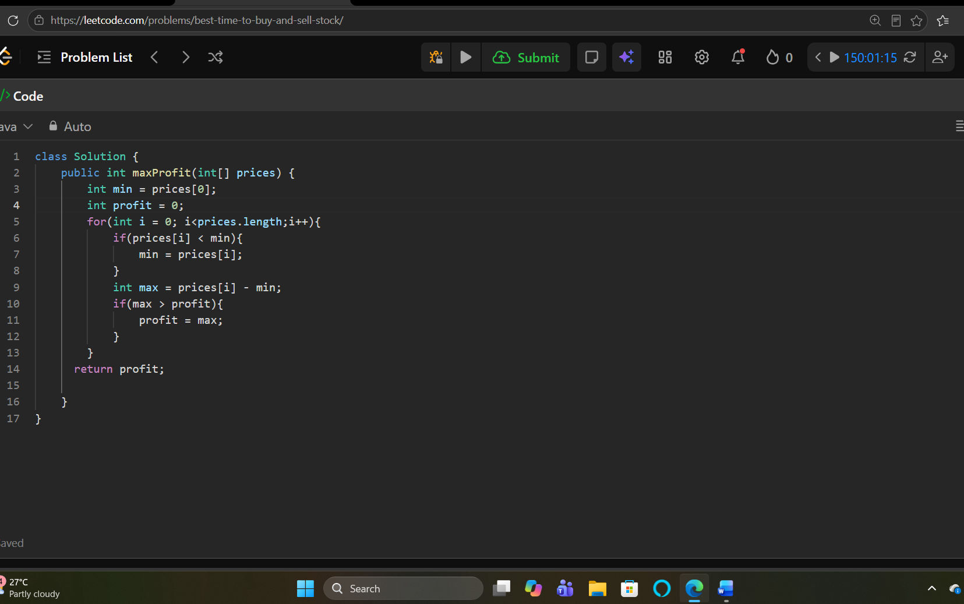
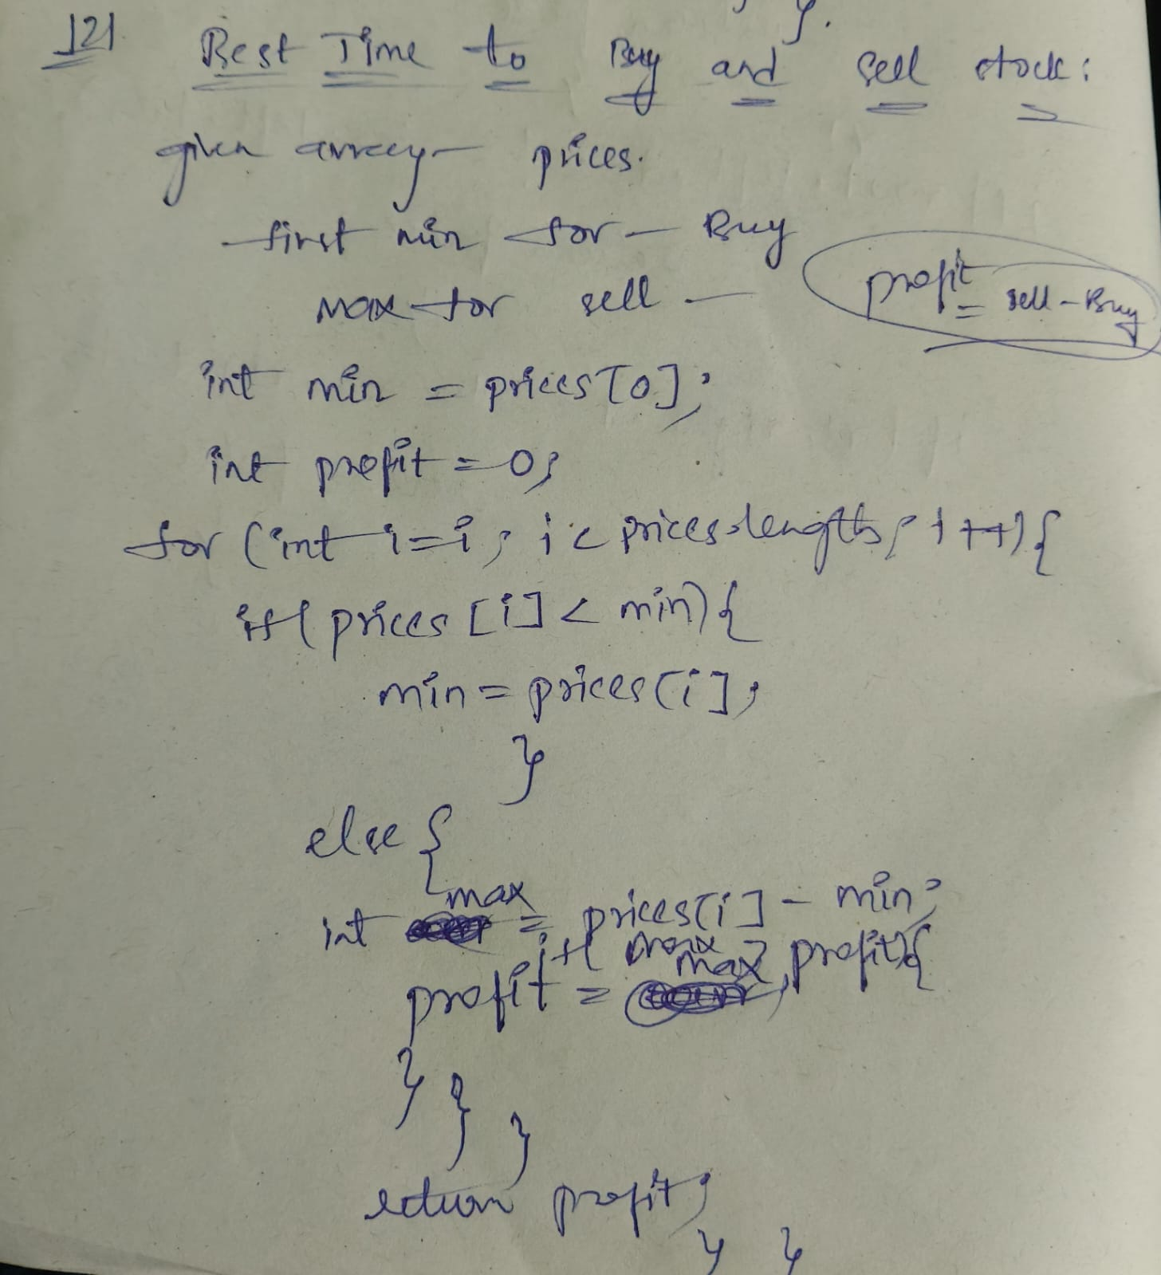

3. Move Zeroes LC-283
https://leetcode.com/problems/move-zeroes/description/
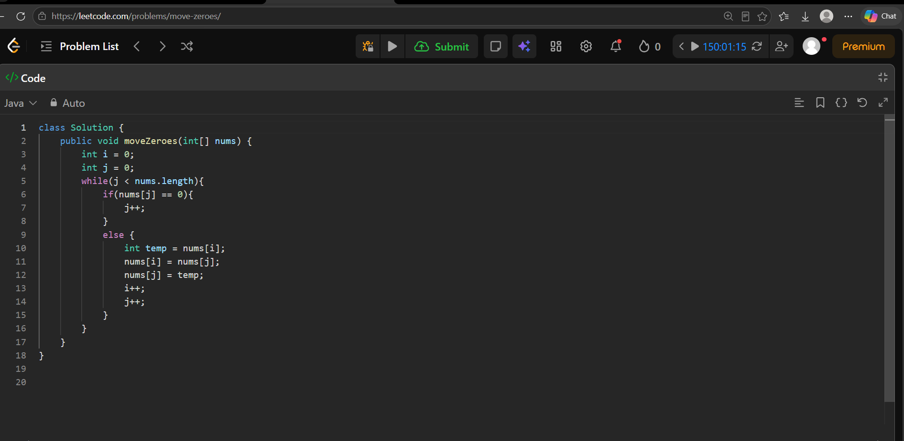

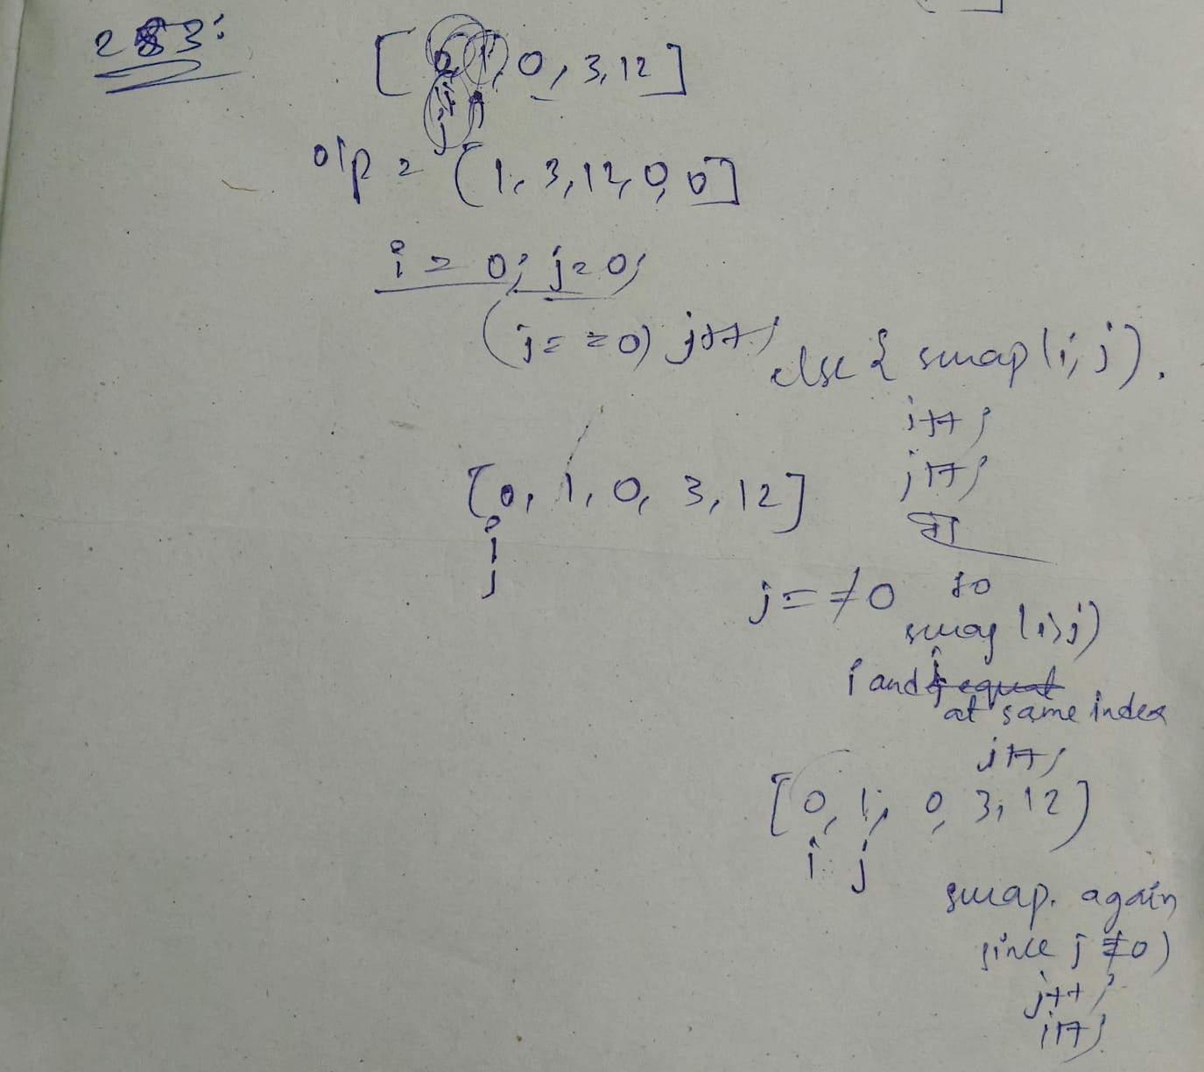

4. Maximum Subarray LC-53
https://leetcode.com/problems/maximum-subarray/description/
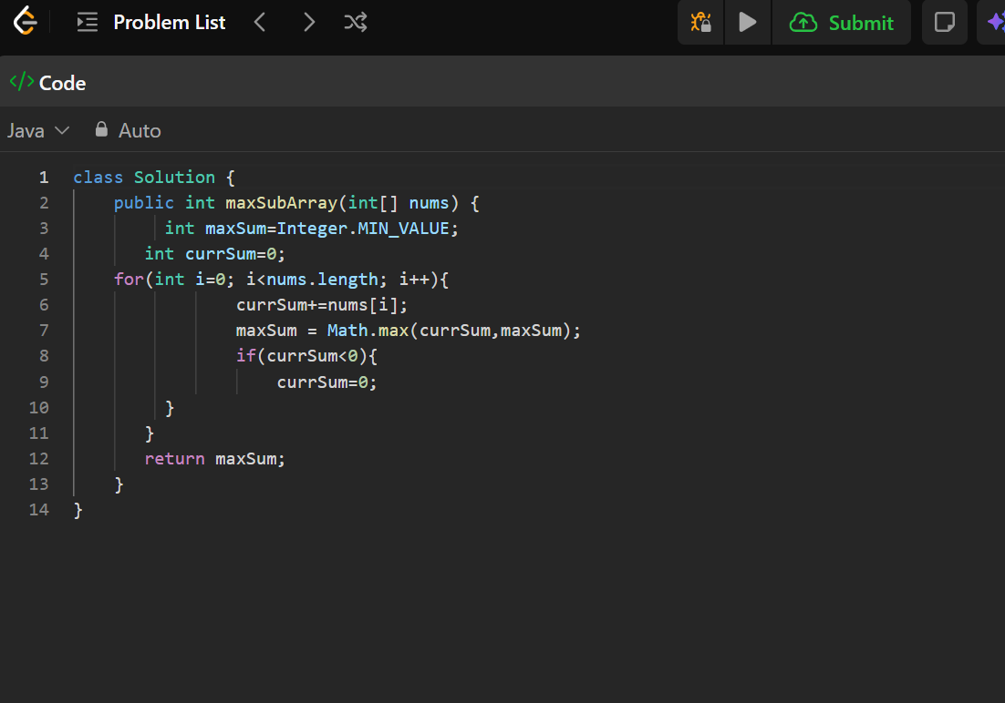

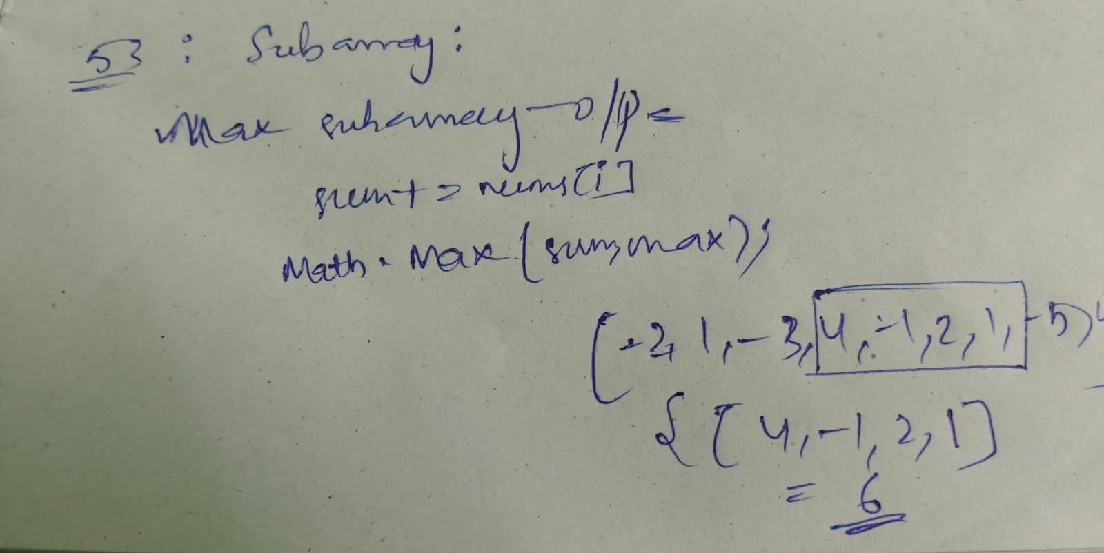
5. Rotate Array LC-189
https://leetcode.com/problems/rotate-array/


